Instructions on how to install the Spot Traffic Downloader

- Download the MSI installer package in the download site on http://spottrafficoperations.com/Default.aspx

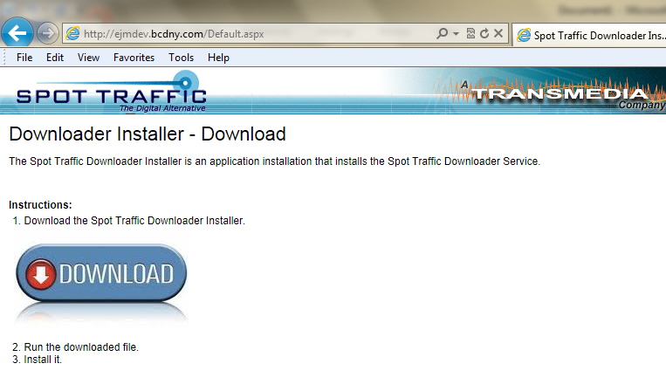

- Run the installer. Click “Next” button.

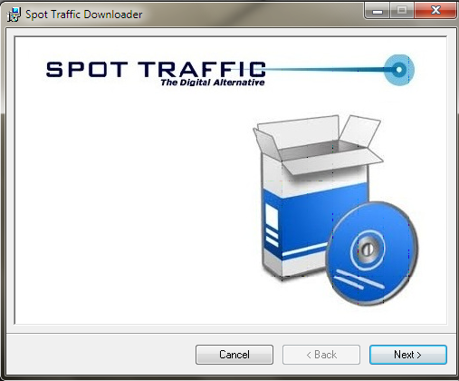

- Click “Next” button.
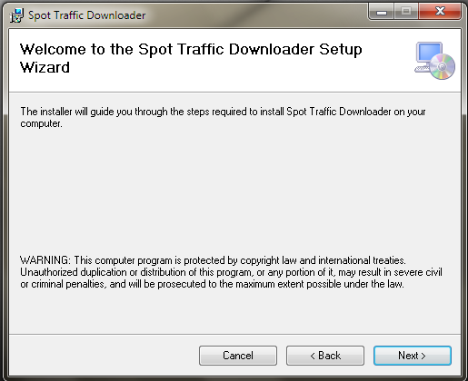

- Specify the details received from the notification and click on the “Next” button.
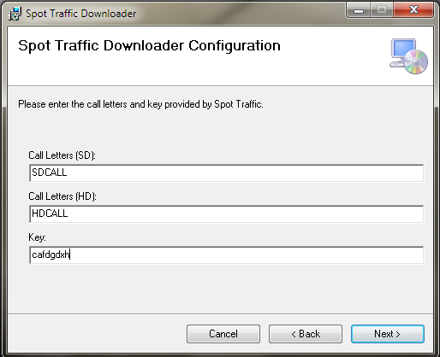

Note: You have to enter the call letters and key correctly on this step as you will have to reinstall the application again if the information entered is wrong.

- Specify the installation folder and click on the “Next” button.
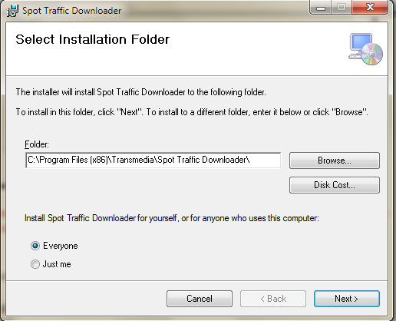

- Click on the “Next” button to confirm the installation.
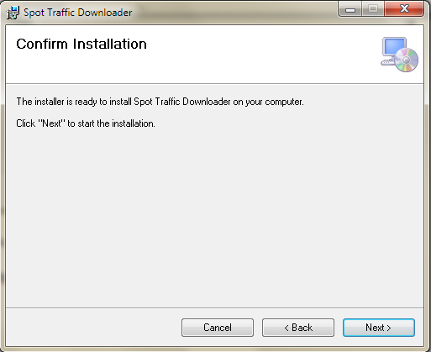

- Click the “Close” button
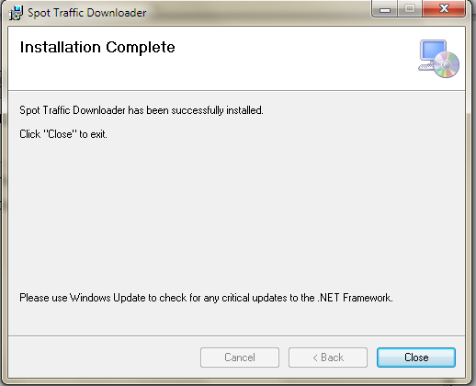

- After the installation is complete, you will then have to wait for a couple of minutes as the downloader might be configuring and downloading the binary files initially.

- You will now be able to setup the downloader settings by going to Start -> All Programs -> Transmedia -> Spot Traffic [Downloader Settings]

